|  |  |  |  |
| --- | --- | --- | --- |
| **Instructor** |  | **Due Date** |  |

**PROJECT** ( **Creating a Menu GUI Application** )

**Objective** To write a program that creates a GUI application that uses a Grid Layout.

***PROJECT DESCRIPTION***

The program code given in **Figure 2** , consists of creating the graphical user interface given in **Figure 1** below. The interface consists of a label field and a set of menu items. The initial program code has the user clicking one of the items on the drop - down menu list and a resulting message is displayed in a message box. You will modify the original program code to perform various tasks, described below, such that the user can click the

Exit to close the application.

**Figure 1**

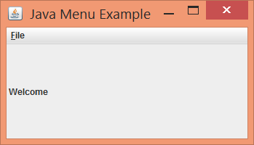

***Information About This Project***

This program illustrates an example of the power of a graphical user interface by using Java swing components.

***Steps To Complete This Project***

**STEP 1**  **Open a Java Text Editor**

If it is not open, launch a Java text editor.

Open a Java text editor such as Eclipse or JCreator. Create a Java file using the name **JavaMenus** since this is the class name for this project. When the Java editor opens, type the program code shown in **Figure 2** ,which follows, exactly as it appears. Place your own name, course and project information in a comment block at the top of the code.

The code is written such that a one column menu GUI component is constructed.

**PROJECT ( Creating a Menu GUI Application )**

**Figure 2 Program Code for Java Menu File**

|  |
| --- |
|  |

|  |
| --- |
| **import** javax.swing.*;  **import** java.awt.event.*;  **public** **class** JavaMenus **extends** JFrame {  **public** JavaMenus()  {  **super**("Java Menu Example");    JMenu file = **new** JMenu("File");  file.setMnemonic('F');  JMenuItem ItemNew = **new** JMenuItem("New");  ItemNew.setMnemonic('N');  file.add(ItemNew);  JMenuItem ItemOpen = **new** JMenuItem("Open");  ItemOpen.setMnemonic('O');  file.add(ItemOpen);  JMenuItem ItemExit = **new** JMenuItem("Exit");  ItemExit.setMnemonic('x');  file.add(ItemExit);    **final** JLabel label1 = **new** JLabel(" Welcome");  add(label1);  **this**.setSize(100, 100);  setVisible(**true**);    ItemNew.addActionListener(  **new** ActionListener() {  **public** **void** actionPerformed(ActionEvent e)  {  label1.setText(" New");  JOptionPane.*showMessageDialog*(**null**, "New was Clicked",  "Result", JOptionPane.*PLAIN_MESSAGE*);  }  }  );  ItemOpen.addActionListener(  **new** ActionListener(){  **public** **void** actionPerformed(ActionEvent e)  {  label1.setText(" Open");  JOptionPane.*showMessageDialog*(**null**, "Open was Clicked",  "Result", JOptionPane.*PLAIN_MESSAGE*);  }  }  ); |

|  |
| --- |
|  |

**PROJECT ( Creating a Menu GUI Application )**

**Figure 2 Program Code for Java Menu File ( continued )**

|  |
| --- |
|  |

|  |
| --- |
| ItemExit.addActionListener(  **new** ActionListener(){  **public** **void** actionPerformed(ActionEvent e)  {  label1.setText(" Exit");  JOptionPane.*showMessageDialog*(**null**, "Exit was Clicked",  "Result", JOptionPane.*PLAIN_MESSAGE*);  }  }  );  JMenuBar bar = **new** JMenuBar();  setJMenuBar(bar);  bar.add(file);    getContentPane();  setSize(250, 250);  setVisible(**true**);  }    **public** **static** **void** main(String[] args)  {  JavaMenus appMenu = **new** JavaMenus();  appMenu.setDefaultCloseOperation(JFrame.*EXIT_ON_CLOSE*);  }  } |

|  |
| --- |
|  |

**STEP 3**  **Compile, Execute and Test the Program**

After you have typed the given program code, build, compile and execute the program. Observe the graphical user interface that opens when the application is executed.

Test the operation of your program. Click the New menu item. The following message dialog box appears.

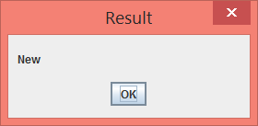

**PROJECT ( Creating a Menu GUI Application )**

Also the label within the application changes its text.

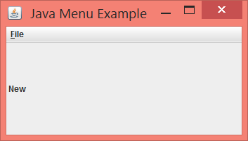

**STEP 4**  **Modify the Program Code**

Modify your program code for the **JavaMenus.java** file such that the program will include a new menu item. To do this alter the menu component items scheme to appear as follows.

|  |  |
| --- | --- |
| Open Item | A Graphic image appears drawn out in the Frame |
| New Item | A historical quote appears in the Frame along with a corresponding image related to the quote.  Example- picture of Steve Jobs along with a Jobs quote of sorts. |
| Edit Item | A message box appears with the user’s name. |
| Exit Item | The application exits. |

Test your modified program.

**STEP 5**  **Supplement the Program Code**

Modify again your program code for the **JavaMenus.java** file such that the program will include a new second column of menu items. To do this alter the menu bar such that it will contain these items.

|  |  |
| --- | --- |
| Welcome Item | A message box appears that describes the program. |
| About Item | A message box appears with your name, as the programmer and version number of the app. |

**STEP 6**  **Submit the Project**

Submit your completed project, in the usual fashion.